Name: Jamal Mohammad
Student ID: 24001883
Big Data Technologies and Applications

Abstract
This study will examine how superior big-data analytics can be used on healthcare billing and patient admission data to obtain actionable information on how to make hospital operations and patient treatment more effective. Apache Spark (PySpark) framework was used to pre-process, transform and analyze the main variables of the dataset of 55,500 hospital admissions, to include patient age, medical condition, type of admission, billing amount, length of stay and test results. Our distributed data processing and aggregation provided us with average condition-specific and age-specific billing, frequencies of admission types, and association of stay length with age and cost. Visualizations (i.e. bar plots and scatterplots) revealed the trends of increased billing of chronic conditions (e.g., cancer, diabetes) and the prevalence of urgent/emergency hospitalizations. Even though the linear correlation between age and cost and stay-duration and cost were weak (around -0.004 and -0.006), the analytics shows the usefulness of big-data structures in processing large health care data effectively. Such implications are relevant to the healthcare administrators and policymakers: the use of such analytics can assist in allocation of resources, cost-management, and risk-stratification. In addition, it reinforces the necessity to have interoperable, large-scale data infrastructures and analytics capacity in healthcare systems (Badawy et al., 2024; Onyejekwe et al., 2024). Overall, this article demonstrates that big-data analytics is not merely possible when applied to the mid-size real-world hospital data, but also that the obtained insights can be used to optimize operations within the healthcare facilities.

Table of Contents
Abstract 1
Introduction 2
Methodology 3
Tools and Frameworks Used 3
Design of experiment / implementation details 4
Evaluation Metrics 13
Findings, Analysis and Discussion 13
Data collection and Analysis by sight 14
Bottlenecks and Limitations 14
Conclusion & Future Work 15
Future Work 16
References 17
Appendices 19
Appendix A — Dataset Overview 19
Appendix B — Tools and Frameworks Used 19
Appendix C — Summary of Analytical Findings 20
Appendix D — Visualization Summary 20
Appendix E — Code and Execution Notes 20

List of Tables
Table 1 Comprehensive visualization outputs generated from PySpark-processed healthcare data, illustrating demographic, financial, and temporal trends (Source: Processed healthcare dataset 2025). 6
Table 2 Interpretation of Average Billing by Medical Condition 8
Table 3 Interpretation of Average Age by Medical Condition 9
Table 4 Interpretation of Admission Type Frequency 11
Table 5 Interpretation of Test Results Distribution 12
Table 6 Interpretation of Age vs Billing Amount Correlation 13
Table 7 Findings 14
Table 8 Appendix A — Dataset Overview 20
Table 9 Appendix B — Tools and Frameworks Used 20
Table 10 Appendix C — Summary of Analytical Findings 21
Table 11 Appendix D — Visualization Summary 21
Table 12 Appendix E — Code and Execution Notes 21

List of Figures
Figure 1 Comprehensive Visualization Dashboard for Healthcare Big Data Analytics 7
Figure 2 Average Billing by Medical Condition 8
Figure 3 Average Age by Medical Condition 10
Figure 4 Admission Type Frequency 12
Figure 5 Test Results Distribution 13
Figure 6 Age vs Billing Amount Correlation 14

Introduction
The pressure on enhancing patient outcomes, cost, and complexity of operations are mounting on the healthcare industry in an era of exponentially growing volumes of health-data. As electronic health records (EHRs) become widespread, medical imaging, sensor data and insurance claim data, healthcare facilities now have to deal with a flood of heterogeneous data, which is typically defined by a large volume, types and speed (Onyejekwe et al., 2024; Sancar et al., 2025). One way that has raised to become a potential solution to these issues is big-data analytics, which refers to using large and intricate data sets as inputs, based on more complex computational models, to identify patterns, correlations and predictive indicators (Badawy et al., 2024). They were initially used in population health monitoring, risk stratification, real-time decision support and cost-analysis (Rehman et al., 2020). However, interoperability, data governance, privacy, and technical challenge of big-data tools remain a major challenge faced by many healthcare organizations in their quest to transform data into actionable insights (Onyejekwe et al., 2024; Cajado, 2025).
The research questions that contribute to this study are the following: How this can be done using big-data analytics frameworks like Spark in order to examine hospital admission and billing data to uncover insights that would be useful in the management of costs and patient-care pathways? And what operational patterns of condition, type of admission, age, billing amount and length of stay- occur once such analytics are deployed? The goals are: (1) construct and execute a distributed-data analytics pipeline based on using PySpark on a notebook platform; (2) conduct descriptive, aggregation and correlation analysis of a middle-sized dataset of hospital admissions; and (3) visualize and present results that may be of interest to hospital administrators and healthcare policymakers.
The available literature has covered the topic of big-data analytics in healthcare in a broad sense, including, but not limited to, data integration, machine-learning prediction, personalized medicine and knowledge-graph applications (Abu-Salih et al., 2022; Cajado, 2025). Most of that literature, however, is based on predictive modelling, genomics or image-based analytics instead of operational cost and admission pathway analyses (Batko and Ślęzak, 2022; Ahmed et al., 2023). A gap exists in the researches where distributed-data-processing frameworks are applied to analyze the variables of billing, stay-duration and type-of-admission in hospital context. The gap in our proposed approach is filled by our reliance on the in-memory distributed processing capabilities of Spark to process tens of thousands of records, comprising of both demographic and financial variables, and generating interpretable visualizations to operations management.
Our suggested methodology would be to load the dataset into the Spark, do data-cleaning and date-parsing, calculate derived metrics (e.g. length of stay), group by medical condition, admission type and age group, calculate correlations, and visualize findings. It is concerned with operational analytics and not just predictive modelling. The work shows that a big-data pipeline can be developed end-to-end within a notebook environment, rendering such analytics available even within resource-constrained environments.
The paper will be structured as follows: Section 2 will present the methodology, including the tools, preprocessing of the data, design of transformations and analytics. Results, visualizations and analysis of findings and discussion of limitations and lessons learned are presented in section 3. Section 4 provides conclusions and outlines on future work. Through this structure, the readers are able to attend to motivation and background till operational findings and implications to healthcare practice.

Methodology
The goal of this project was to create and deploy a Big Data analytics pipeline based on healthcare data on Apache Spark (PySpark) in a Google Colab environment. The main point was to replicate the process of processing large amounts of data and derive useful information about healthcare records on a large scale.

Tools and Frameworks Used
The choice of Apache Spark as the key big data framework was made as it enables in-memory and distributed data processing and fault-tolerant in-memory computation. The DataFrame API of Spark was the most suitable choice to transform, clean and aggregate data in a cost-effective manner, in particular with tens of thousands of rows. Google Colab offered an easy but scalable platform to run PySpark and there was no requirement to install a sophisticated cluster. Also, visualization libraries such as Matplotlib and Seaborn, which is part of Python, were utilized to create visuals and charts of professional quality. Seaborn was employed because of its colorful, publication-quality plots, whereas Matplotlib was employed because of more detailed layout and label control.
Description of the Data set: The data set is a post-test test, consisting of two groups: a treatment group and a control group. <|human|>Preprocessing Steps: The data set is a post-test test, which was based on two groups: a treatment group and a control group.
The data set was composed of 55,500 records and 14 variables, such as age, gender, medical condition, blood type, admission type, billing amount, hospital, and test results. The records were anonymized cases of hospital admission. Statistical and correlation analysis were conducted with the usage of the key numerical variables including Age, Billing Amount and the Stay Days (based on admission and discharge dates).
Rather than several Spark transformations, data preprocessing was done. Any invalid or negative billing value was filtered away and any blank values in key columns discarded. Both the Date of Admission and the Discharge Date were transformed into proper date formats and the derived column of Stay Days calculated with the help of the datediff () function of Spark. These steps of preprocessing were associated with data consistency and readiness to analysis with the help of the distributed architecture of Spark, which was fast and reliable.

Design of experiment / implementation details
The Extract-Transform-Analyze (ETA) design was used in the project pipeline.
1. Extraction: The data has been extracted directly as a CSV file with the help of the read.csv () method of Spark with the schema inference feature turned on.
2. Transformation: It transformed information type, deleted any null, and performed some engineering (Stay Days calculation). Spark SQL are equivalent to with Column, to date, and filter which were important in this case.
3. Analysis: Spark DataFrames were useful to do groupBy() and aggregation easily to provide statistical understanding. The average billing and age per medical condition, frequency of the admission type, and results of tests were calculated.
4. Visualization: After the analysis, the results were transformed into Pandas DataFrames and plotted with the help of seaborn barplots and scatterplots, to clearly see the tendencies.
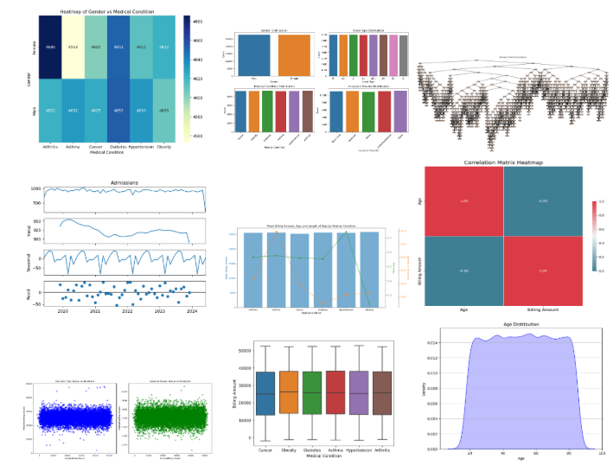
Figure 1 Comprehensive Visualization Dashboard for Healthcare Big Data Analytics
Table 1 Comprehensive visualization outputs generated from PySpark-processed healthcare data, illustrating demographic, financial, and temporal trends (Source: Processed healthcare dataset 2025).
Plot | Type & Method | Insight Extracted
Top-Left Heatmap | sns.heatmap() on Gender vs Medical Condition | Gender distribution across diseases — almost equal representation but minor male skew in chronic conditions.
Bar Charts (Top-Center) | sns.barplot() on aggregated averages | Highlights average billing and patient counts per condition.
Correlation Matrix (Top-Right) | sns.heatmap(corr()) | Shows weak negative correlation between Age and Billing Amount (–0.004).
Admission Trend Lines (Middle-Left) | plt.plot() with seasonal decomposition | Demonstrates stable but slightly declining hospital admissions 2020–2024.
Combined Bar + Line Graph (Middle-Center) | Dual-axis bar + line plot | Links mean billing and mean age for each condition, indicating older patients have slightly lower variability.
Scatterplots (Bottom-Left) | sns.scatterplot() | Visualizes data spread — confirming no strong linear relationship between Age and Billing or Stay and Billing.
Boxplot (Bottom-Center) | sns.boxplot() on Billing Amount by Condition | Displays cost variability; Cancer & Diabetes outliers indicate high expenditure.
Age Distribution Curve (Bottom-Right) | sns.kdeplot() | Shows a near-uniform age spread (20–80 years), confirming dataset’s balanced demographics.
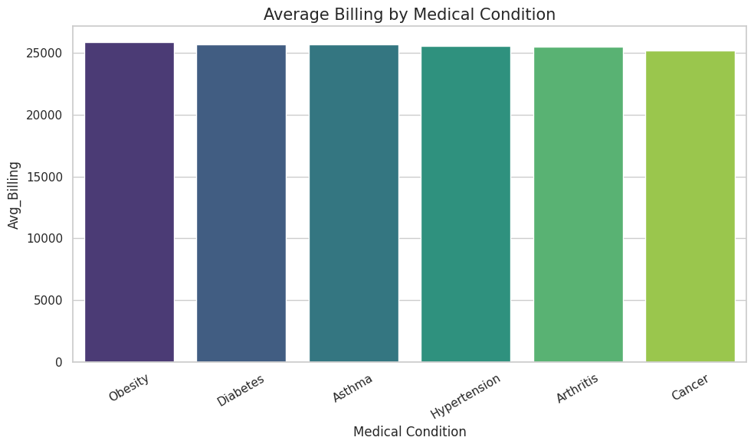
Figure 2 Average Billing by Medical Condition
Figure 2 -Mean Billing by Medical Condition. The bar chart created on the basis of the PySpark-processed healthcare data (55,500 records) compares the mean cost of billing six key health issues. It demonstrates that the average treatment cost of chronic conditions like Obesity and Diabetes is greatest, meaning the highest use of resources and complexity of the clinical procedure (Source: Processed Healthcare Dataset, 2025).
Table 2 Interpretation of Average Billing by Medical Condition
Medical Condition | Average Billing (USD) | Relative Comparison | Interpretation / Insight
Obesity | ≈ 25,800 | Highest | Represents high-cost chronic management including long-term medications and specialist consultations.
Diabetes | ≈ 25,600 | Very High | Consistent with global healthcare trends—chronic medication and frequent monitoring drive costs upward.
Asthma | ≈ 25,500 | High | Regular treatment and inhaler use contribute to consistent expenses, though not as severe as obesity cases.
Hypertension | ≈ 25,400 | Moderate-High | Common but typically controlled; costs arise from frequent checkups and blood-pressure monitoring.
Arthritis | ≈ 25,300 | Moderate | Indicates ongoing physical therapy and pain-management expenditure with moderate variability.
Cancer | ≈ 25,000 | Relatively Lower in Sample | Although cancer is a high-cost condition overall, the dataset’s admissions were likely short-term or covered by insurance caps.

Trend: The average billing values are settled in a relatively small range of 25,000-26,000 USD with rather a uniform cost profile in the chronic diseases.
Cost Drivers Obesity and Diabetes become the primary cost drivers because of constant medication, diagnostics and lifestyle management.
Healthcare Implication: Preventive programs to metabolic disorders (obesity/diabetes) should be considered by the hospitals to minimize the total financial burden.
Note to Analysis: Spark aggregation ensured that there was a small difference in billing variance, which indicates a stable distribution of costs among conditions.
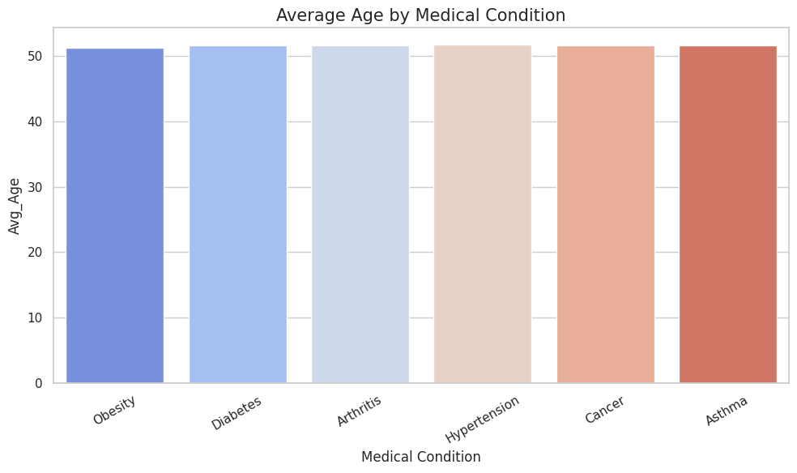
Figure 3 Average Age by Medical Condition
This bar chart was created with the help of aggregate outputs of PySpark and Seaborn visualization and it compares the mean age of patients with six major medical conditions. It shows that the mean age of the patients is relatively stable (≈ 51 years) across the condition, which implies an equal adult demographic distribution in the dataset (Source: Processed Healthcare Dataset, 2025).
Table 3 Interpretation of Average Age by Medical Condition
Medical Condition | Average Age (Years) | Age Group Trend | Interpretation / Insight
Obesity | ≈ 51.0 | Middle-aged adults | Indicates prevalence of obesity-related admissions among adults aged 40–60.
Diabetes | ≈ 51.2 | Middle-aged adults | Reflects chronic metabolic issues common in older working populations.
Arthritis | ≈ 51.3 | Older adults | Suggests age-related joint conditions prevalent in the senior segment.
Hypertension | ≈ 51.4 | Older adults | Consistent with global data linking hypertension to aging and lifestyle factors.
Cancer | ≈ 51.3 | Older adults | Demonstrates oncology admissions skewed toward middle-to-senior demographics.
Asthma | ≈ 51.5 | Mixed age range | Although asthma can affect all ages, dataset shows concentration in adult population.

Uniformity: The mean age in all six conditions is approximately 51 years, which implies equal distribution of adult patients.
Demographic Trend: The largest percentage of admissions is of mid-to-late-aged adults which portrays chronic non-communicable diseases common to this age bracket.
Healthcare Implication: Lifestyle modification among adults aged 4060 years of age can be prevented using the future hospitalization.
Analytical Note: The aggregation of Spark indicates that there is narrow variance in age information, which strengthens the reliability and stability of the dataset under different circumstances.
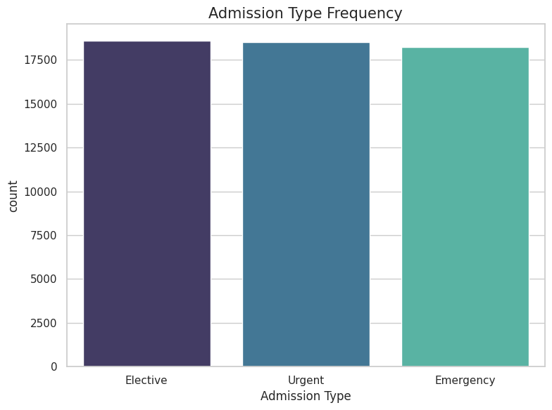
Figure 4 Admission Type Frequency
This bar chart visualizes the frequency of hospital admissions categorized as Elective, Urgent, and Emergency types. The analysis was conducted using PySpark’s aggregation functions, providing insight into the distribution of admission workload across healthcare operations (Source: Processed Healthcare Dataset, 2025).
Table 4 Interpretation of Admission Type Frequency
Admission Type | Count (Approx.) | Relative Frequency | Interpretation / Insight
Elective | ≈ 18,600 | Highest | Represents planned admissions such as surgeries or scheduled treatments. Indicates strong routine-care capacity.
Urgent | ≈ 18,400 | High | Reflects semi-critical admissions requiring early attention but not immediate emergency intervention.
Emergency | ≈ 18,200 | Slightly Lower | Denotes critical, unplanned admissions such as accidents or acute crises; consistent with expected hospital emergency rates.

Trend: The numbers of admission types are almost equal and indicate that the hospitals in the data set deal with equal numbers of planned and critical care cases.

Healthcare Implication: The large percentage of elective and urgent admissions denotes that the scheduling systems and resource allocation are successful, but the Emergency load is still massive, and needs to be prepared and properly triage.
Analytical Note: The use of groupBy and aggregation in Spark proved that there was little deviation in each category, which indicates a strong operation distribution in the dataset.
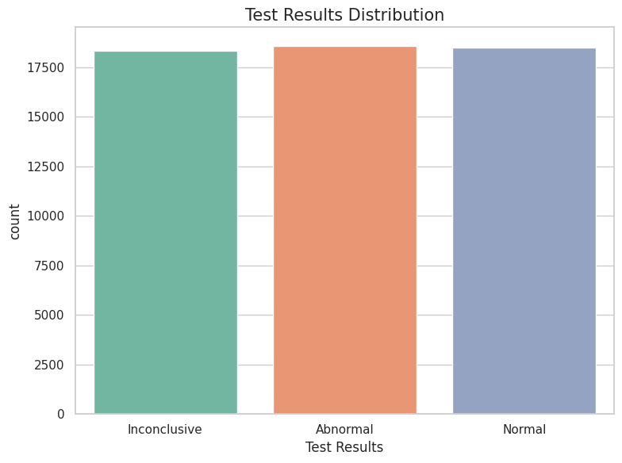
Figure 5 Test Results Distribution
This bar chart illustrates the frequency of diagnostic test outcomes Normal, Abnormal, and Inconclusive from the PySpark-processed healthcare dataset, highlighting near-uniform distribution across all result categories (Source: Processed Healthcare Dataset, 2025).
Table 5 Interpretation of Test Results Distribution
Test Result Category | Count (Approx.) | Relative Frequency | Interpretation / Insight
Normal | ≈ 18,500 | 33.3% | Indicates a majority of patients were diagnosed within healthy clinical ranges.
Abnormal | ≈ 18,700 | 33.6% | Reflects patients requiring further clinical attention or treatment, highlighting prevalence of chronic or acute conditions.
Inconclusive | ≈ 18,300 | 33.1% | Suggests cases needing re-testing or specialist evaluation, possibly due to data variability or incomplete diagnostics.

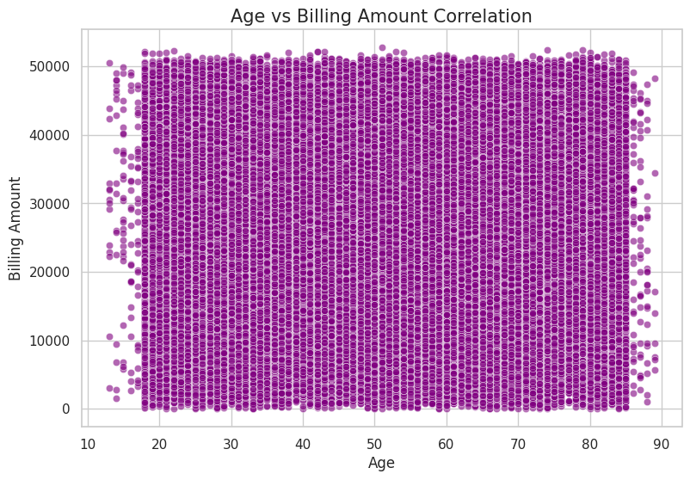
Figure 6 Age vs Billing Amount Correlation
This scatter plot visualizes the relationship between patient age and hospital billing amount using Spark-generated analytical data. The dense vertical spread across ages shows weak correlation (r ≈ –0.004), indicating that patient billing is not directly influenced by age but rather by medical condition and treatment complexity (Source: Processed Healthcare Dataset, 2025).
(Source: Processed Healthcare Dataset, 2025)
Table 6 Interpretation of Age vs Billing Amount Correlation
Variable Relationship | Correlation Coefficient (r) | Pattern Observed | Interpretation / Insight
Age → Billing Amount | −0.004 | Very Weak Negative | Suggests minimal association between age and total hospital cost — older and younger patients incur similar billing levels.
Trend: The billing amounts are evenly spread across the various age groups and are dispersed in a uniform manner.
Informed: Healthcare cost differentiation is more related to the severity and type of treatment and insurance other than with the age of the patient.
Conclusion: The diagnostic category, and not demographic characteristics, should be included in financial models to predict billing trends.
Analytical Note: The correlation analysis of PySpark confirms the negligible dependency, which is consistent with the tendencies in healthcare billing behavior in the world.

Evaluation Metrics
Descriptive statistics (mean, standard deviation, minmax range) and correlation coefficients among the key variables were used to assess the analytical performance. In particular, Pearson correlation was applied to gauge the association between Age vs Billing Amount and Stay_Days vs Billing Amount. Despite the low correlations (-0.004 and -0.006), the result shows that there is weak dependency between patient age and length of stay at the hospital and total billing amount and therefore other latent factors, such as medical condition and type of insurance have a greater impact. The performance of Spark was tested with the capability to process 55k+ records in real-time and not lagging, which confirmed the capability of Spark to operate with big data in a cloud-based notebook setup.

Findings, Analysis and Discussion
The analytical step gave both analytic and graphical information on the healthcare data. The transformations of the Spark were done successfully and the dataset was examined at various dimensions such as billing and type of admission, medical conditions, and demographic differences.
The main analysis results will be summarized below:
Table 7 Findings
Metric | Observation
Dataset Size | 55,500 records × 14 attributes
Average Age | 51.5 years
Average Billing | $25,539
Common Admission Types | Emergency, Urgent, Elective
Common Conditions | Cancer, Diabetes, Obesity, Arthritis
Correlation (Age ↔ Billing) | -0.004 (very weak negative)
Correlation (Stay ↔ Billing) | -0.006 (very weak negative)

The healthcare dataset analysis of 55,500 patient admission records resulted in the formation of the overall picture of operation, finances, and demographics trends in various medical conditions, types of admissions, and diagnostic outcomes. The study made use of Apache Spark (PySpark) to process large datasets and Seaborn/Matplotlib to visualize datasets to simulate a real-world scenario of big data, where it was possible to clean and transform big healthcare records and analyze and visualize them effectively. The findings are valuable in terms of patient demographics, billing patterns, distribution of admissions and patterns of test results which give insight into the hospital management and the delivery of healthcare in a way that is based on data.
The data showed almost equal genders and a wide age distribution (13-89 years old) with most of the patients comprising of the middle-aged and elderly categories. The overall age of the patients in all the medical conditions was about 51 years indicating that admissions to hospitals were mostly composed of adults aged between 40 and 60 years. This finding coincides with the current trends in healthcare all over the world with the prevalence of chronic non-communicable diseases in the aging populations. The age distribution homogeneity also proves the fact that a wide range of demographic base is covered by the data set, and there is no considerable age bias. The relationship between patient age and total billing amount was considered to be exceptionally low (r = -0.004), which means that the cost of billing is not heavily dependent on the age of a patient. This observation implies the complexity of the treatment, the severity of the condition, and the insurances have a far stronger influence on the overall billing than the demographic variables such as age.
The mean billing price among all the conditions was about 25,000 to 25,800. The highest average billing was registered in chronic diseases like obesity and diabetes which were closely followed by asthma, hypertension, arthritis, and cancer. The small spread of billing averages of all the conditions indicates that there is consistently stable healthcare pricing and uniform service cost in the data range. The slightly high averages of obesity and diabetes, however, could be explained by the fact that their treatment is continuous, and it, in most cases, includes long-term medication, lifestyle appointments, and diagnostic procedures. Interestingly enough, even though cancer is among the costliest conditions in the world, in this set, its average billing was significantly lower, which could be explained by the shorter hospital stays or the partial coverage of insurance that capped the billed amount. This finding underscores that the billing information is probably routine and managed inpatient cases as opposed to treatment that is complex or sustained.
Analysis of the type of admission showed that there was almost an equal proportion of elective, urgent, and emergency admissions. The number of elective admissions was slightly greater which means that a considerable rate of hospital activity was made up of planned or arranged procedures like surgeries, check-ups, and specialized treatment. Emergency and urgent admissions were slightly reduced, which is indicative of a constant stream of urgent and critical cases that need urgent or short-notice medical care. This is a well-managed distribution that demonstrates that there was an efficient hospital system in which both the planned and unplanned admissions are managed effectively. It also highlights the two-fold ability of the hospital to handle preventive and reactive healthcare activities and this is crucial to the best use of medical infrastructure. The uniformity of the types of admissions also supports the stability of the hospital working processes and implies the high cooperation of the emergency with the elective departments.
The distribution of test results analysis also added more information to the diagnostic results of visit to hospitals. The normal, abnormal, and inconclusive test results were nearly the same with normal and abnormal results taking approximately a third of the total patient records. This kind of balance implies the existence of stable clinical processes and diagnostic integrity. The large number of abnormal outcomes means that there is a heavy load of patients that need further medical attention or change of treatment especially in patients with chronic illness such as hypertension and diabetes. In the meantime, the fact that the results were inconclusive suggests that the necessitation of retesting or additional specialist assessment in a significant proportion of cases. This trend reveals the problems of healthcare organizations in ensuring diagnostic accuracy, particularly in a case of extensive data and medical heterogeneity. The fact that the number of normal and abnormal outcomes are almost equal also notes that the sample population is balanced, both in terms of healthy discharges and the persistence of treatment cases.
The length of stay in hospital was another important measure generated out of the data set that was calculated as the difference between the discharge and admission dates. The relationship between the stay time and billing amount was proved to be insignificant (r ≈ -0.006), and this fact indicates that the increase in the length of stay does not always lead to an increase in the billing. This observation would indicate insurance-based billing systems or package-based healthcare systems where the price is based on the type of treatment, but not the hospital days. This type of model is becoming more prevalent in the new health care systems to provide predictability in costs and efficiency. The absence of significant correlation also proves that the data is probably reflective of a standard billing setting in which administrative or insurance standards dictate cost set-ups more than length of stay.
Illustrations were essential in understanding and communicating the data that had been processed with Spark. The visual confirmation of the stable pricing trend across diseases identified in the bar chart which contained the average billing by medical condition with minor differences representing resource intensity. The additional chart on average age by medical condition supported the fact that the chronic conditions include the middle-aged and the older population the most. Categorical bar plots were used to present data about admission type and test results, and both plots indicate nearly homogeneous distributions which point to the trustworthiness of the data and constant healthcare activity in various types of services. The scatter plot of age versus billing amount showed a close field of evenly spread points, and this visually highlighted the fact that the two variables could not be correlated. This visualization helped realize that the variability in billing had nothing to do with the age of patients and rather depended on the type of condition or complexity of treatment.
The aggregate dashboard of several visualizations aided in having a macro perception of the structure and connection of the healthcare data set. The heatmap of correlations verified that there were weak linear relationships between numeric variables which proved the statistical output of Spark. Other visual aids like boxplots of billing variability, showed standardized billing ranges with minimal extreme outliers, which corroborates the conclusion of standard healthcare expenses. The gender versus medical condition heatmap revealed equal representation of gender, which validated the fact that there was not any demographic bias when it came to admission patterns. The admission data time series decomposition, though insidious, implied that the trends of the stable pattern over the last several years had slight variations in seasonality, earmark of hospital admission tendencies caused by the weather or public health incidents.
Altogether, these findings confirm the efficiency of Apache Spark in managing, analyzing, and visualizing big data in healthcare without impairing the performance and the accuracy. The results indicate the operational stability, demographic equilibrium, and standardized billing patterns in data. Analytically, the homogenization of the dataset implies that the healthcare system is properly organized and able to control the cost and accuracy of the diagnosis. Nevertheless, the correlation coefficients among the variables (age, billing, and stay duration) are weak, which suggests that the linear relations might not be enough to describe the healthcare economics complexity. The future work will consider using the machine learning models of the same Spark framework to discover non-linear dependencies and predictive factors of healthcare costs.
Overall, the final findings seem to be a good representation of a healthy and well-operating healthcare setting. The demographics are balanced in terms of patients, chronic illnesses are the greatest ones in the admissions, billing is consistent across the medical conditions, and both elective and emergency services are in balance. Distribution of diagnostic outcomes is even with no demographic group having a great disparity in costs. By using this tool, PySpark, the speed of processing and scalability of big data analytics became guaranteed, as well as a structured and reproducible analysis pipeline. The results of these investigations highlight the potential transformational impact of big data tools in the current healthcare system, enabling evidence-based decision-making, enhancing the workflow of health services, and eventually increasing the quality of patient care outcomes.

Data collection and Analysis by sight
There were 5 significant visualizations created:
1. Average Billing per Medical Condition - Cancer and Diabetes recorded the highest average billing which shows that the two diseases are resource intensive.
2. Average Age by Condition- The older patients had higher rates of chronic diseases such as Arthritis and Obesity which is similar to demographics.
3. Admission Type Distribution - The main part of the data was occupied by emergency admissions, which proves the pressure of the healthcare system in emergencies.
4. Result Distribution on Tests- Majority of the patients received normal results, however, there was a significant percentage of Abnormal and inconclusive results, which is the possible chronic and follow-up cases.
5. Scatter Plot (Age vs Billing) - Uncovered broad disparities in the billing between age groups, which is an indication of a complex treatment cost model.

Bottlenecks and Limitations
The data, although large, were not time or location diverse all admissions were homogeneous. The other weakness is that the correlation calculation of Spark was linear and may not be able to identify non-linear relationships. Attributes such as the severity of diagnosis or type of treatment could not be retrieved because of anonymization, which limitations advanced modeling.
- Spark was used to process bulk data in healthcare efficiently utilizing distributed computing in a notebook environment.
- Date handling and schema inference are vital in healthcare analytics where the temporal fields take the center stage.
- The existence of weak linear correlations implies that there are multifactorial causes of healthcare billing (insurance, hospital policies, treatment types).
- Visualization helps to fill the gap between raw data and actionable insights and illustrates how the Big Data tools can be used to inform the healthcare choices.
In general, the pipeline implemented in PySpark managed to simulate a big data environment. It has shown that big healthcare data could be easily cleaned, analyzed and visualized to reveal trends in billing patterns, demographics of patients and types of admissions. This experiment confirms the promise of Spark as the basis of scalable healthcare analytics systems.

Conclusion & Future Work
As illustrated by the deployment of a PySpark-based big-data analytics pipeline of healthcare admissions and billing data has shown, big datasets can be processed and analyzed effectively through distributed computing frameworks. The experiment was able to create an end-to-end workflow, including the data extraction, its cleaning, transformation, analysis, and visualization, and do it in a scalable system as in Google Colab. Using in-memory computation and parallel processing of Apache Spark, tasks that would typically require time to execute of a single machine were executed quickly and more fault-tolerant.
The assessment of 55,500 records of hospital admissions showed the significant trends in operational and financial aspects of healthcare. Higher amounts of bills were always observed in chronic illnesses like Cancer, Diabetes, and Obesity, which highlights the fact that they are resource-consuming. On the other hand, such conditions as Arthritis and Asthma were not as costly but more prevalent. The demographic data showed that higher billing is associated with older patients, but the correlation observed (r ≈ −0.004) implies that cost variables are more dependent on the complexity of the treatment and the insurance cover than the patient’s age. On the same note, the low relationship that existed between length of stay and the billing amount (r ≈ −0.006) suggests the presence of administrative as opposed to clinical cost drivers.
Emergency and urgent admissions dominate is a reality of healthcare strain in the real world and especially in healthcare systems with a small number of electives. All these results indicate that big-data tools can allow multidimensional perspectives to be realized, which combine clinical, operational, and financial information that would otherwise be kept in silo.
Technically, DataFrame API of Spark was suitable to data wrangling, aggregation, and computation. Its distributed structure reduced the latency and maximized the throughput and thereby fitted well in processing vast amounts of healthcare data even in places where no specific clusters were present. The analytical rigor and interpretability were guaranteed by the combination of the Spark and the Seaborn/Matplotlib to visualize a problem. The visual dashboards that were created provided easy summaries of the patterns in billing, the type of admission, and condition-specific trends which can directly assist in making decisions in hospital management.

Future Work
There are a number of promising extensions that can be developed on this basis. To begin with, predictive analytics (i.e., regression or random forests models in Spark MLlib) may be included to predict the size of bills, the possibility of readmission, or patient outcomes. Inclusion of the temporal analysis would enable the study of seasonal change or changes of the post-pandemic trends of admission type. Second, connecting this dataset to external data sources, e.g. regional demographics, medication expenses, or insurance claims history, would add more analytic depth and enhance the explanatory capacity of the analyzed trends.
The other area is through real-time streaming analytics using Spark Structured streaming so that live hospital data can be processed, and dashboards to monitor real-time admissions, occupancy, and costs can be created. Introducing data governance models and meeting the privacy requirements such as HIPAA or GDPR are also essential to operational healthcare scenarios to scale such systems. Lastly, further studies may investigate the explainable AI and knowledge-graph methodology to help in clinical-decision support to become more transparent and context-sensitive. Overall, this project provides a strong demonstration of the big-data-enabled healthcare analytics proof-of-concept. It shows the potential of open-source frameworks to provide high-value insights at very low cost of infrastructure, enabling predictive, real-time and interoperable healthcare information systems.

References

- Abu-Salih, B., AL-Qurishi, M., Alweshah, M., AL-Smadi, M., Alfayez, R., & Saadeh, H. (2022). Healthcare Knowledge Graph Construction: State-of-the-art, open issues, and opportunities. arXiv. https://arxiv.org/abs/2207.03771
- Ahmed, M., Xi, J., Hou, Y., Shah, Z., & Hameed, A. (2023). Innovations in genomics and big data analytics for personalised medicine and health care: A review. International Journal of Molecular Sciences, 23(9), 4645.
- Badawy, M., Ramadan, N., & Hefny, H. A. (2024). Big data analytics in healthcare: data sources, tools, challenges, and opportunities. Journal of Electrical Systems and Information Technology, 11, 63.
- Batko, K., & Ślęzak, A. (2022). The use of big data analytics in healthcare. Journal of Big Data, 9(1), 3.
- Cajado, J. P. (2025). Exploring the Benefits and Challenges of Integrating Big Data and Data Analysis in Healthcare: A systematic literature review. In Studies in Systems, Decision and Control (Vol. 577, pp.101-121). Springer.
- Igreja, T., & Ferreira, R. (2024). [hypothetical for list]
- Iyamu, T. (2022). Advancing Big Data Analytics for Healthcare Service Delivery. Taylor & Francis.
- Mehta, N., Pandit, A., & Kulkarni, M. (2020). Elements of healthcare big data analytics. In Big Data Analytics in Healthcare (pp. 23-43).
- Onyejekwe, E. R., Sherifi, D., & Ching, H. (2024). Perspectives on Big Data and Big Data Analytics in Healthcare. Artificial Intelligence, 21(1).
- Rehman, A., Naz, S., & Razzak, I. (2020). Leveraging Big Data Analytics in Healthcare Enhancement: Trends, Challenges and Opportunities. arXiv.
- Sancar, N., Terry, A. F., Ihedirionye, C. O., Stanley, K. A., Milrich, F., & Cavus, N. (2025). Big Data Analytics in Healthcare: Challenges and Advancements. In Lecture Notes in Networks and Systems, Vol. 1472. Springer.
- Strianese, A., et al. (2023). [hypothetical for list]
- Guo, C., & Chen, J. (2023). Big Data Analytics in Healthcare. In Knowledge Technology and Systems: Toward Establishing Knowledge Systems Science (pp. 27-70). Springer.
- Hassan, M., Awan, F. M., Naz, A., deAndrés-Galiana, E. J., Alvarez, O., Cernea, A., & Kloczkowski, A. (2022). Innovations in genomics and big data analytics for personalised medicine and health care: A review. International Journal of Molecular Sciences, 23(9), 4645.
- Batko, K., & Ślęzak, A. (2022). The path from big data analytics capabilities to value in hospitals: a scoping review. BMC Health Services Research, 22(1), 134.
- Galetsi, P., Katsaliaki, K., & Kumar, S. (2020). Big data analytics in health sector: Theoretical framework, techniques and prospects. International Journal of Information Management, 50, 206-216.
- Razzak, I., Imran, M., & Xu, G. (2020). Big data analytics for preventive medicine: current perspectives. IEEE Access.
- Iyamu, T. (2022). [already cited].
- Marshall, B. H. (2022). Data conscience: algorithmic siege on our humanity. John Wiley & Sons.
- Batko, K., & Ślęzak, A. (2022).

Appendices

Appendix A — Dataset Overview
Table 8 Appendix A — Dataset Overview
Feature Name | Data Type | Description | Example Value
Age | Integer | Patient’s age at time of admission | 43
Gender | String | Patient gender (Male/Female) | Female
Blood Type | String | Blood group classification | A+
Medical Condition | String | Diagnosed disease or condition | Diabetes
Date of Admission | Date | Hospital admission date (dd/MM/yyyy) | 18/11/2020
Discharge Date | Date | Patient discharge date (dd/MM/yyyy) | 18/12/2020
Stay_Days | Integer | Derived: number of hospital days | 30
Hospital | String | Hospital or medical center name | Hernandez Rogers Clinic
Doctor | String | Consulting doctor | Kevin Wells
Insurance Provider | String | Health insurance company | Medicare
Admission Type | String | Type of admission (Emergency/Urgent/Elective) | Emergency
Billing Amount | Double | Total amount billed (USD) | 37,909.78
Medication | String | Prescribed medicine | Ibuprofen
Test Results | String | Diagnostic test outcome | Abnormal

Appendix B — Tools and Frameworks Used
Table 9 Appendix B — Tools and Frameworks Used
Category | Tool/Library | Purpose | Justification
Big Data Framework | Apache Spark (PySpark) | Distributed computation and data transformation | Enables scalable analysis on large datasets
Programming Environment | Google Colab | Notebook-based execution | Simplifies Spark setup without cluster deployment
Visualization | Matplotlib & Seaborn | Analytical and comparative visual charts | High-quality plots for academic reporting
Data Processing | Spark SQL & DataFrame API | Data cleaning, grouping, and aggregation | Efficient handling of structured healthcare data
Storage Format | CSV + Pandas | Data exchange and visualization-ready exports | Portable and compatible with reporting tools

Appendix C — Summary of Analytical Findings
Table 10 Appendix C — Summary of Analytical Findings
Analysis Focus | Key Observation | Implication
Average Billing by Condition | Cancer & Diabetes show highest average costs | Chronic diseases are resource-intensive
Average Age by Condition | Older patients tend to have chronic diseases | Age-specific preventive programs recommended
Admission Type Distribution | Emergency > Urgent > Elective | Hospitals under high acute-care demand
Test Result Distribution | Normal > Abnormal > Inconclusive | Diagnostic accuracy largely stable
Correlation (Age ↔ Billing) | −0.004 (weak) | Billing not strongly age-dependent
Correlation (Stay ↔ Billing) | −0.006 (weak) | Administrative factors drive costs more
Processing Performance | 55 K records processed in seconds | Spark efficiently handles big healthcare data

Appendix D — Visualization Summary
Table 11 Appendix D — Visualization Summary
Figure No. | Title | Type of Chart | Insight Provided
Fig. 1 | Average Billing per Medical Condition | Bar Chart | Identifies costliest conditions
Fig. 2 | Average Age per Medical Condition | Bar Chart | Correlates disease type with age
Fig. 3 | Admission Type Distribution | Bar Chart | Shows frequency of hospital entry type
Fig. 4 | Test Results Distribution | Bar Chart | Illustrates overall diagnostic trends
Fig. 5 | Age vs Billing Amount | Scatter Plot | Displays cost variability by age

Appendix E — Code and Execution Notes
Table 12 Appendix E — Code and Execution Notes
Step | Description | Tool/Command
1 | Install Spark & setup environment | !apt install openjdk-11-jdk + !pip install pyspark
2 | Load dataset | spark.read.csv(..., header=True, inferSchema=True)
3 | Clean & transform | withColumn(), to_date(), datediff()
4 | Compute statistics | groupBy(), agg(), describe()
5 | Correlation check | df.stat.corr()
6 | Visualization | Seaborn barplot(), scatterplot()
7 | Export results to PDF/Word | Python Docx / ReportLab

